Logbook Week 6
February 24, 2026

On the sixth week we:
- Started work on the midterm report. We will continue working on it as the week passes until it’s due next week
- We continued finalizing the design and specifications of substations. By “specifications” we mean dimensions of parts, type of material, and so on. For example, we did some rough sketches of how the rice dispensing machine will work:

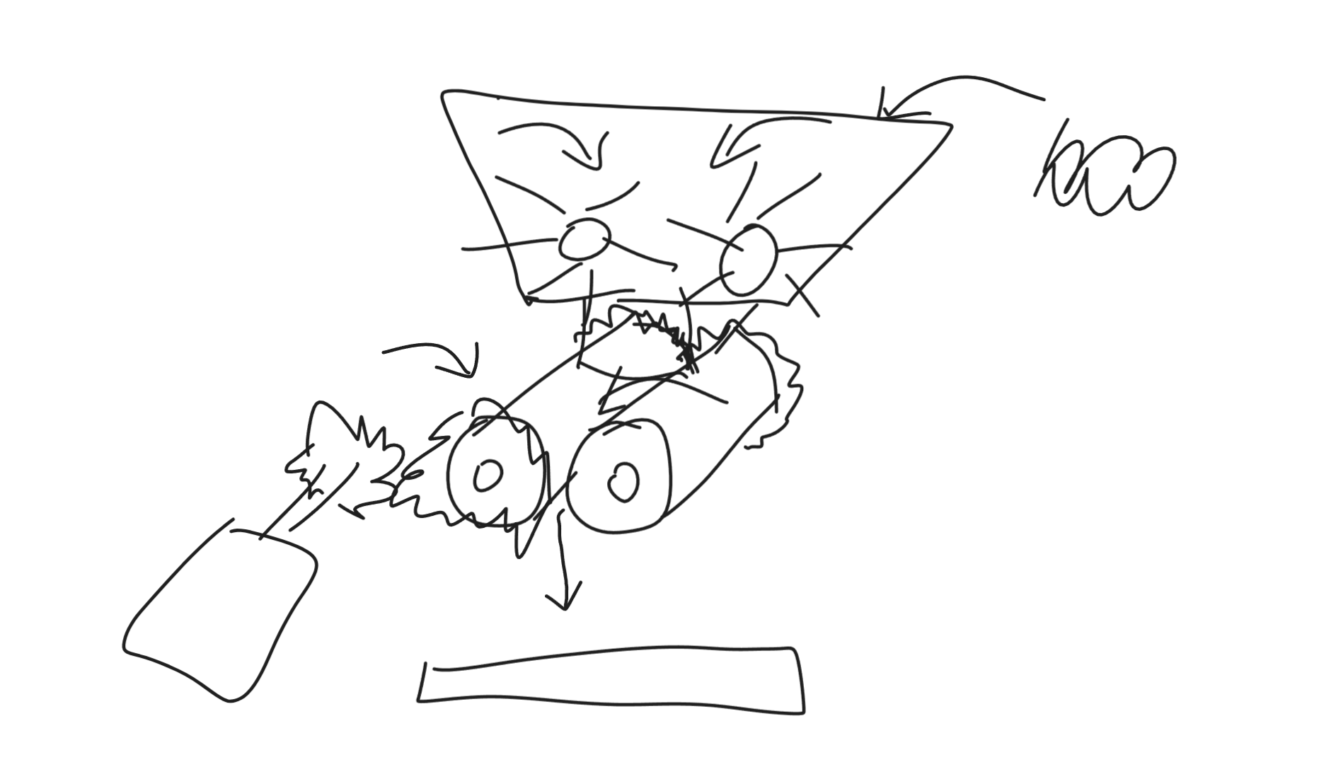
- This is me starting the Specifications section in our OneNote notebook:
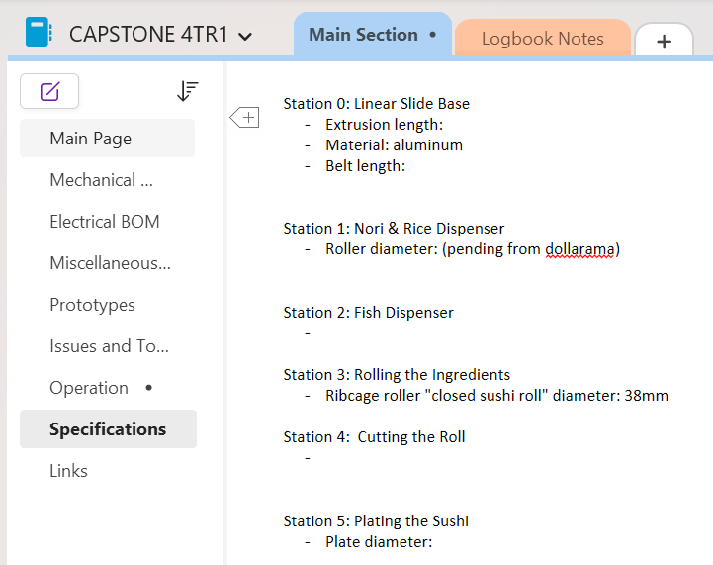
The more specific we can get with dimensions and materials, the faster we can get to actually designing it on CAD, then building it and testing it.
- We also worked on the design of the fish dispensing substation. We thought our old idea of the spinning wheel was inadequate because we did not know what extra value it added to our machine versus just the user manually putting the fish on themselves. We decided that if we were to create a fish dispensing machine, it would have to do one or both of these two things to be useful:
  - Able to preload multiple waves of fish for multiple batches of sushi, and dispense them automatically when the platform gets to the substation
  - Places the fish in a way that is more precise than what the user can do
- We decided to mostly focus on the first point. We are going to create a new design for the fish dispenser that allows preloading of multiple waves of ingredients, and possibly multiple ingredients, not just fish, such as avocado:
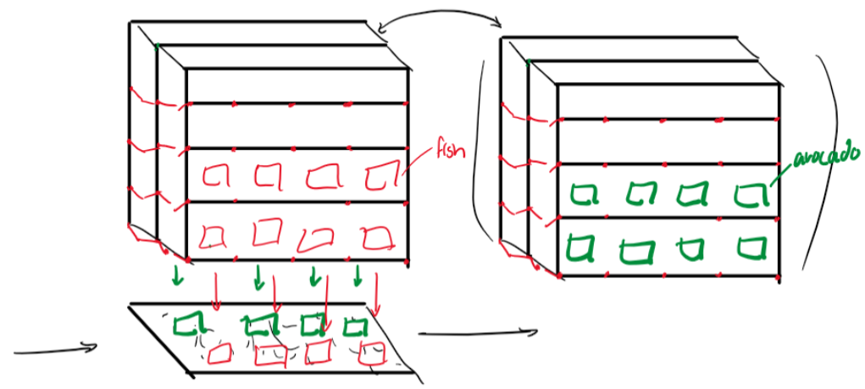
- This is a rough sketch of our idea. We think we can make a multi-level trapdoor system that will be controlled by a few motors and the code in our microcontroller.

Things we will work on next week:
- Find out the hole thread size of the table we’re building on and the full dimensions of hole spacing (IMPORTANT for CAD progress). Perhaps there is a physical sketch or CAD from whoever made the table? (This task is continued from last week.)
- Jacob wants to start dedicating time to learning how to program our UR robot. (This task is continued from last week.)
- I want to finalize motor part numbers and start importing them into our CAD so that we can start designing the mechanical assembly of our substations. I will also need to research and find where we can buy parts for the mechanical assembly. (This task is continued from last week.)
- I plan to go to the dollar store and buy two roller pins that we will use for our rice dispensing substation. This will decide the dimensions of the rest of the substation, and we will design around them.
- As the week goes by, and for next week, I want to start some 2D sketches with specific dimensions of the substations. I may start with a simple substation first. If we are satisfied with the 2D sketches we will create them 3D in CAD and start planning the parts and materials we will need.

